TEMEKE MUNICIPAL COUNCIL
(All letters should be addressed to the Municipal Director)

Director’s office,
92 Mandela/Taifa road
S.L.P 46343,
15883 - DAR ES SALAAM,

Tel: +255 22-2928132
Fax: +255 22-2928137
Email: temeke@temekemc.go.tz
Website: http//.www.temekemc.go.tz

TENDER NUMBER: LGA/016/2020-2021/HQ/NC/17/LOT 1-4

For

LEASE OF SPACE FOR PROVISION OF SERVICES AT KIJICHI MODERN MARKET IN TEMEKE MUNICIPAL COUNCIL

Invitation to Bid
Date: 2st September, 2020
- Temeke Municipal Council has available spaces for various business opportunities (for Leasing) at Kijichi Modern Market and intends to lease the premises to interested Institutions/Companies/Sole proprietors for provision of various services. It is expected that Temeke Municipal Council will generate more revenues under the contracts and hence improve service delivery to its Markets.

- The Temeke Municipal Council now invites sealed bids from eligible business community for leasing the spaces (Business premises) at Kijichi Modern Market as follows:

LOT | DESCRIPTION OF LOT | ITEM | DESCRIPTION OF BUSINESS | QUANTITY | AREA  (SQM)
1. | Ground Floor – Right | 1 | Bank | 1 | 284m²
2. | Ground Floor - Left | 1 | Bank | 1 | 284m²
3. | First Floor | 1 | Open hall (Super Market) | 1 | 127.5 m²
4. | First Floor | 1 | Restaurant | 1
3. Tendering will be conducted through the National Competitive Tendering Method as specified in the Public Procurement Regulations, 2013 – Government Notice No. 446 and Public Procurement (amended) Regulations, 2016 – Government Notice No. 333 and is open to all national Tenderers as defined in the Regulations.
- Interested eligible bidders may obtain further information from and inspect the bidding documents at the office of The Secretary, Temeke Municipal Council Tender Board, Office of the Procurement Management Unit (PMU) Storage Block Room No. 1, 92 Mandela/Taifa Road, opposite the National Football Stadium, P.O. Box 46343, 15883 Dar es Salaam, Tanzania, Telephone: +255 22 2928132/2928138, Fax No: +255 22 2928137, Email: temeke@tmc.go.tzfrom 07:30 to 15:30 hours local time, Monday to Friday except Saturday, Sundays and public holidays.

5. A complete set of Tendering Document(s) in English language and additional set may be purchased by interested Tenderers on the submission of a written application to Director General, Temeke Municipal Council, and P. O. Box 46343, Dar es Salaam and upon payment of a non-refundable fee as indicated in the table above, Payment should be done through Government Electronic Payment Gateway (GePG) after obtaining Control Number issued by the Director, Temeke Municipal Council.

6. All tenders must be accompanied by a Tender Securing Declaration form in the format provided in the tender document.

7. All tenders in one (1) original plus two (2) copies properly filled in, and enclosed in plain envelopes clearly marked the Tender Number, Lot Number and Description of Business applied for. Do Not Open Before 11.00 Hours, Local Time on, Tuesday 15th September, 2020, must be delivered to the address as follows: -

The Secretary Tender Board,
Temeke Municipal Council
Located opposite to Taifa National Stadium
along Mandela/Manispaa street no 92 and Taifa roads
P.o. Box 46343, Dar es salaam.

8. Deadline for submission will be on Tuesday 16th September, 2020 at 11.00 am. Tenders will be opened promptly thereafter in public and in the presence of Tenderers’ representatives who choose to attend in the opening at the PMU Conference Room in Temeke Municipal Council Head Quarter.

9. Late tenders, portion of tenders, electronic tenders, and tenders not received, tenders not opened and not read out in public at the tender opening ceremony shall not be accepted for evaluation irrespective of the circumstances.

10. Pre-Bid meeting shall take place at Temeke Municipal Conference Hall, Temeke Municipal Council, 92 Mandela/Taifa Road, Dar es Salaam on Friday, September 4, 2020 at 10:00 am, to be followed by a Site Visit.

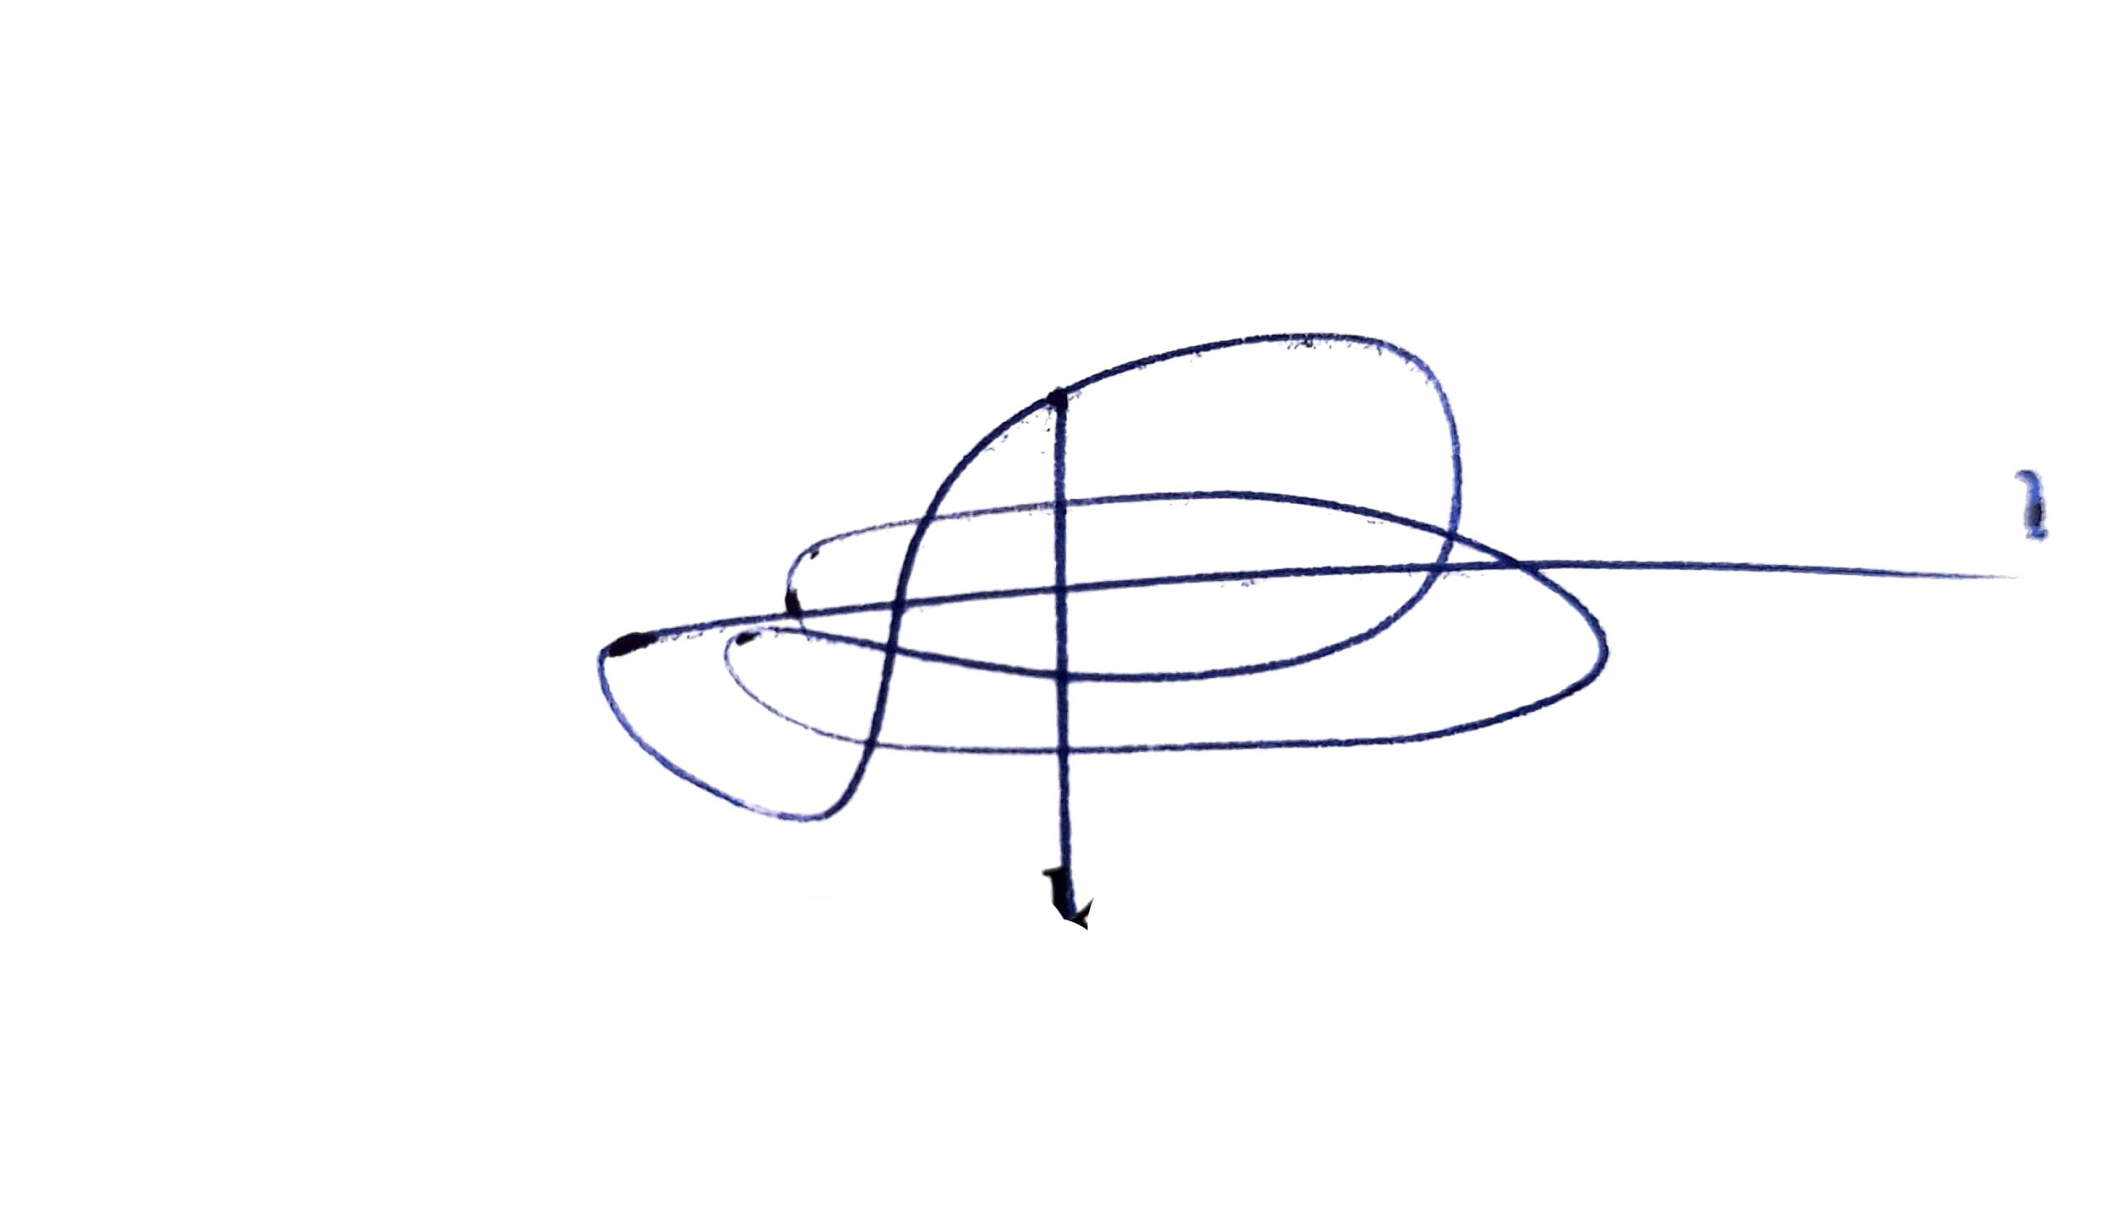
Deogratius Lukomanya
Ag. Municipal Director
Temeke Municipal Council
P. O. Box 46343, Dar es Salaam

